**Project Report**

**Created by: Gihan Abenayake (S3779792),**

**Nicholas Mladenov (s3539747) ,**

**Muhammad Fathur Giorady (s3737757),**

**Thanh Duong (s3601172)**

**Vision Statement**

This product that we have created over our twelve weeks doing this course is a valuable creation due to a variety of reasons. It contains five main features with three extra enhancement features:

* A Registration Feature
* A Login Feature
* A Dashboard Feature
* A Booking Feature
* A User Profile Feature
* Text on field rollover Enhancement
* Kubernetes enhancement
* AWS secret store enhancement

Each feature adds value to the product in its own way.

The Registration feature allows for customers to register into the database in order to create bookings for the services they require.

The Login feature allows for already registered customers to securely

access the site and through this, get access to the other features the product provides.

The Dashboard feature provides an overview of a logged in users Bookings, including their Pending and completed bookings, so that they can see when their next bookings are and if they had any other bookings.

The Booking feature provides users with a way to create an appointment in order to get what tasks they want done. This is accomplished by selecting an employee, then the time they wish to create that appointment for alongside a few other details.

The User Profile feature provides a more indepth look into a users personal details, allowing them to edit various parts of their profile from their name to the organisation they work for. This provides a more customisable feel to the user by allowing them to change what information they display to the admins and employees that select their data. It also contains a timeline of events for them to track in a similar state to the dashboard

**Refactoring Report**

**See Refactoring Report.pdf**

**GitFlow Organisation Overview**

**See Git-Tree.txt in Submission Folder**

**Infrastructure Workspace Diagram**

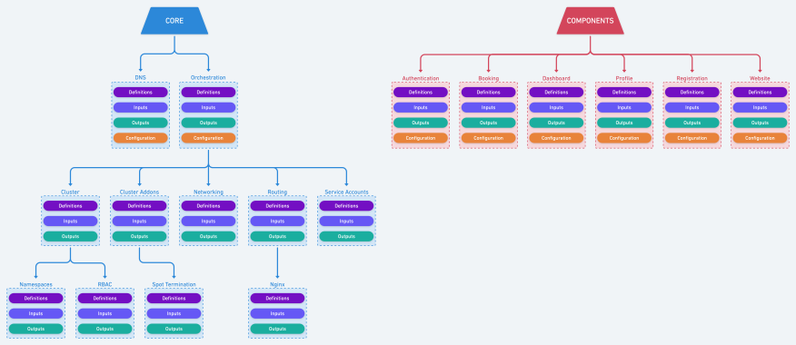

**Infrastructure Release Process Diagram**

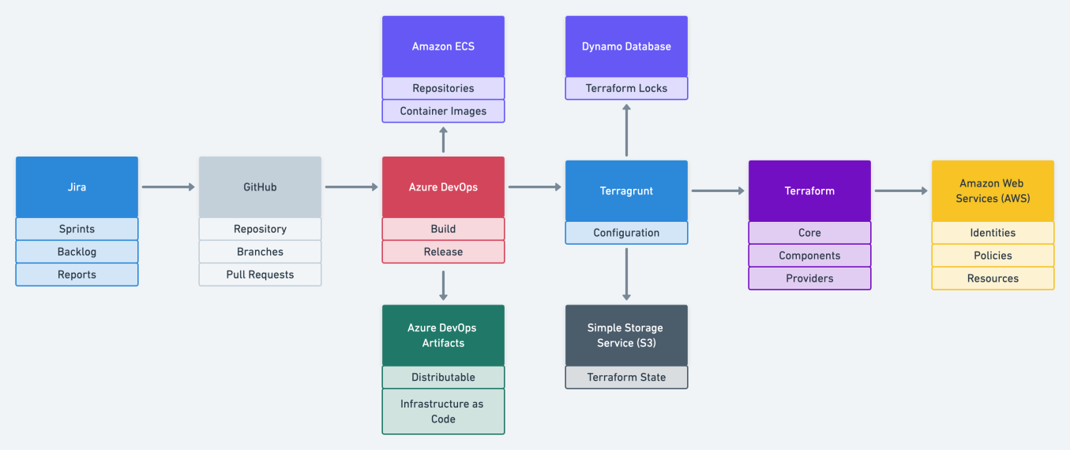

**Basic System Architecture Figure**

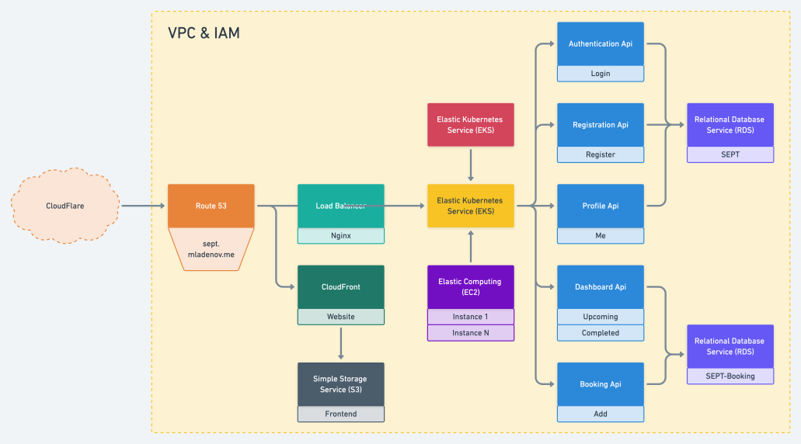

**Scrum Process**

Our Scrum master was : Gihan Abenayake

We met a minimum of two times a week on Mondays and Tuesdays around 6:30pm with extra undocumented meetings as required to help sort out any issues with programming that occured during our later milestones.

**Testing Report**

**See Acceptance Testing Report.pdf**